**Software Design Document**

for

TalkBox

Group 15

York University

EECS2311 Software Development Project

24. March 2019

Contents

Class Diagrams 2

TalkBoxConfig High Level 2

TalkBoxConfig Low Level 3

TalkBoxSim 4

TBCLog 5

Sequence Diagrams 6

TalkBox Configuration 6

Record Audio: 6

Playback Audio from a Button: 7

Update Number of Buttons: 8

Update Button Label: 9

Upload Audio to Buttons: 10

Upload Images to Buttons: 11

Swap Profiles: 12

Save Settings / Serialize Changes: 13

Launch TalkBox Simulator Application: 14

Load/Delete/New Profile: 15

Next/Previous Log: 16

TalkBox Simulator 17

Playback Audio from a Button: 17

Swap Profiles: 18

TalkBox Configuration Log (TBCLog) 19

Next/Previous/Load Log: 19

# Class Diagrams

## TalkBoxConfig High Level

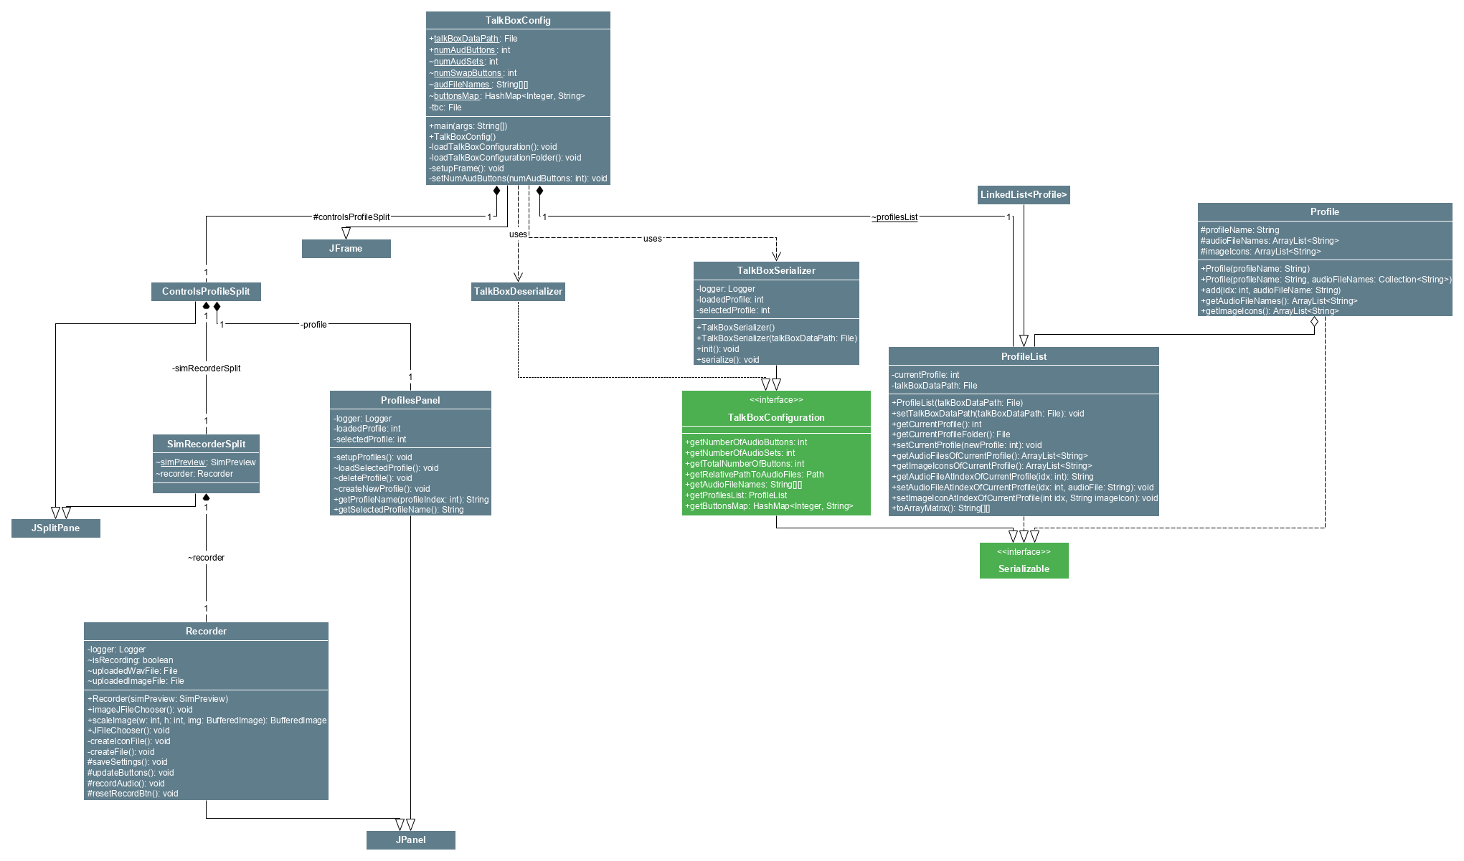

## TalkBoxConfig Low Level

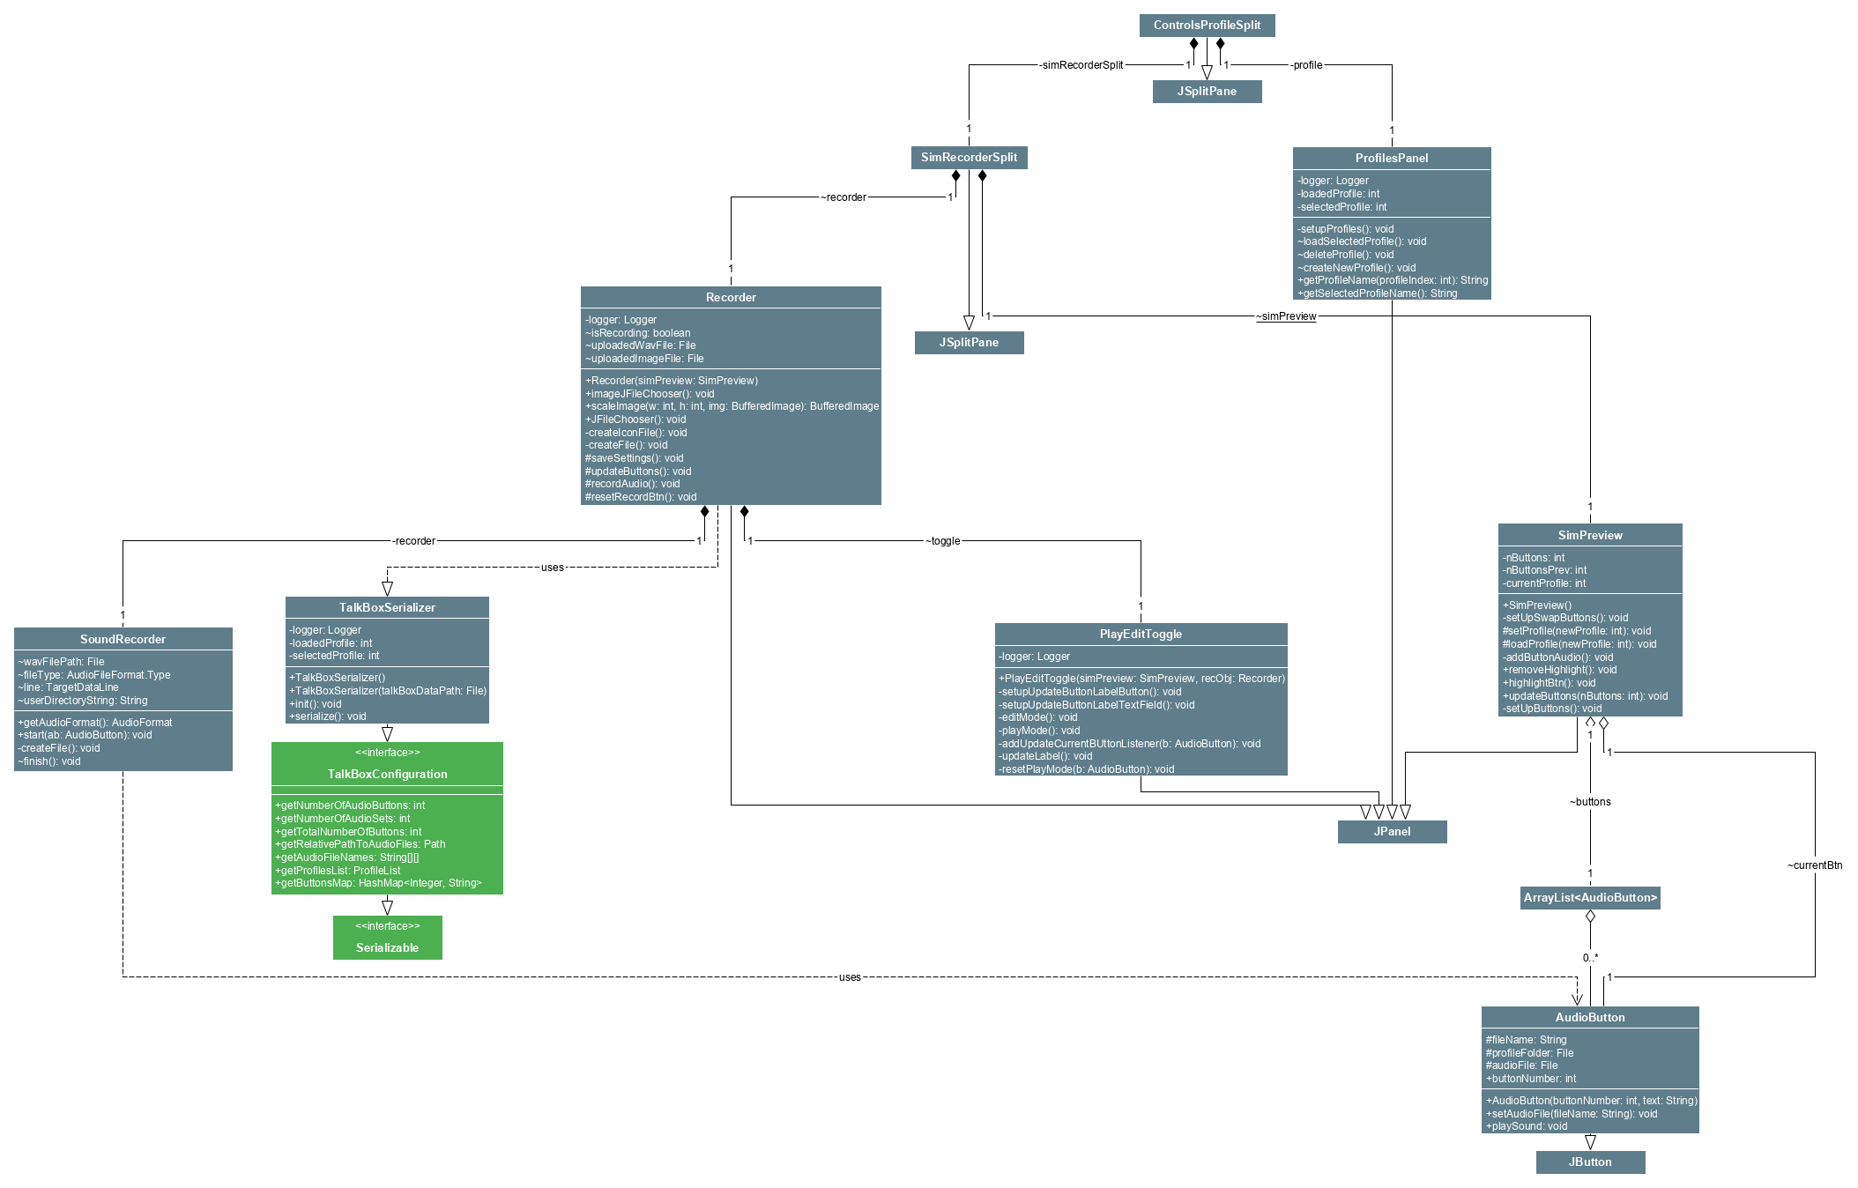

## TalkBoxSim

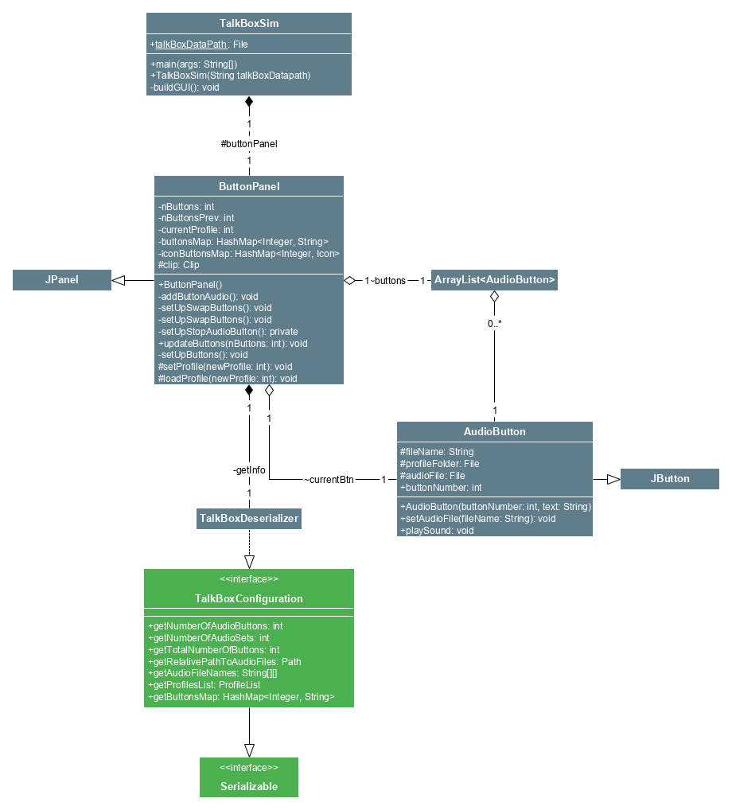

## TBCLog

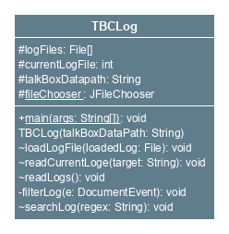

# Sequence Diagrams

## TalkBox Configuration

### Record Audio:



### Playback Audio from a Button:



### Update Number of Buttons:

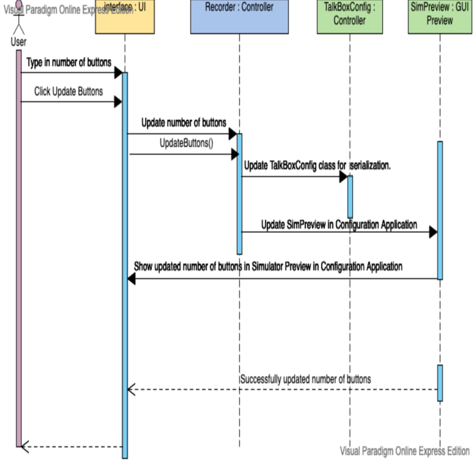

### Update Button Label:

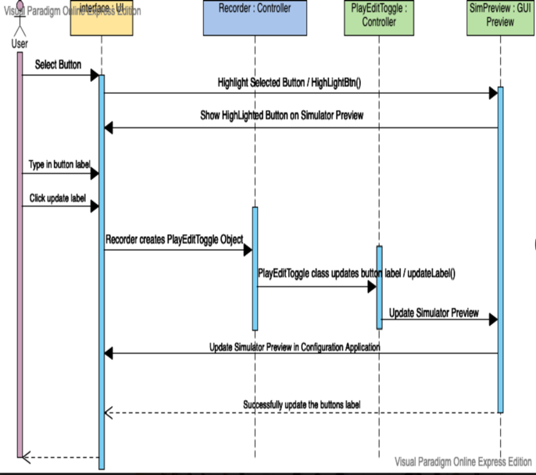

### Upload Audio to Buttons:



### Upload Images to Buttons:



### Swap Profiles:



### Save Settings / Serialize Changes:



### Launch TalkBox Simulator Application:



### Load/Delete/New Profile:



### Next/Previous Log:



## TalkBox Simulator

### Playback Audio from a Button:

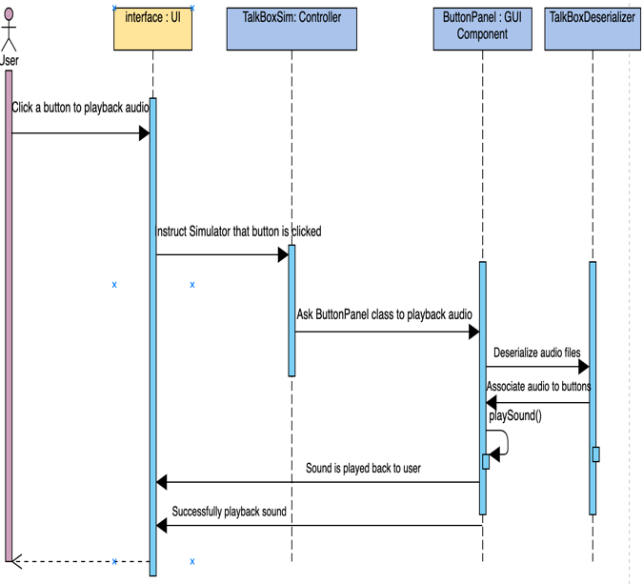

### Swap Profiles:



# TalkBox Configuration Log (TBCLog)

### Next/Previous/Load Log:

